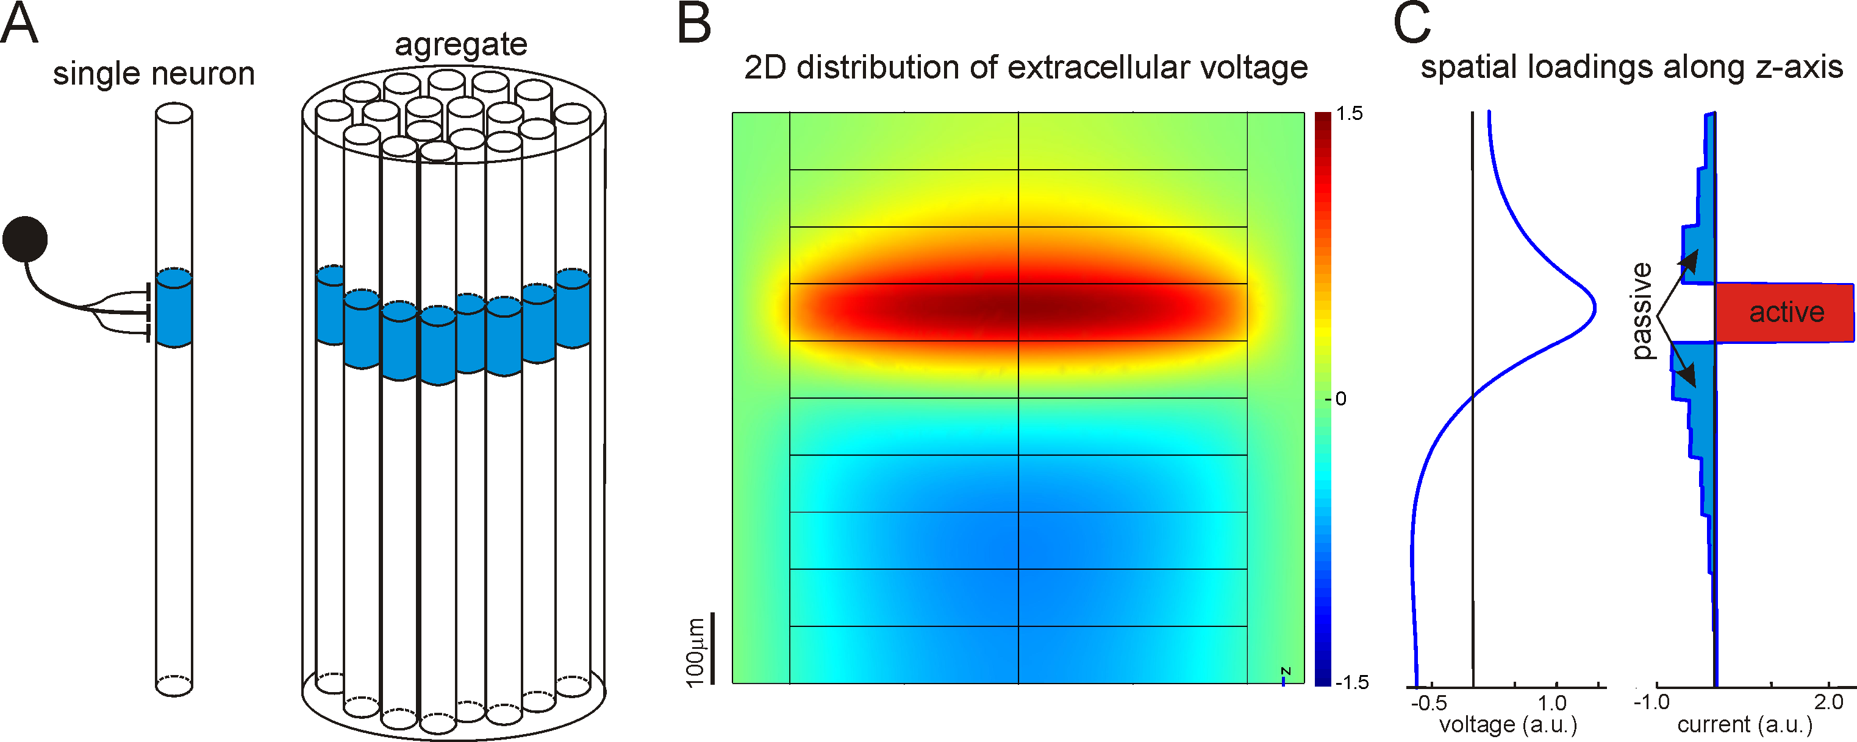
sFig. 4: Synaptic inputs and sandwich-like spatial distribution of the CSD profile. A) Sketch of the model. We model a pyramidal neuron as a cylinder composed of 10 compartments (left). One of the compartments (blue) receives an inhibitory input from an interneuron (black circle). A set of such pyramidal neurons homogeneously distributed in a cylindrical tissue constitute the neuronal aggregate (L = 0.7 mm, d = 0.7 mm). B) Two dimensional projection of the extracellular voltage. C) The derived axial distributions of the voltage and CSD -loadings. Their shapes are similar to the loadings for G1 (see Figs. 2(b), 3(b), and 5(a) in the main text). Notice the sandwich-like distribution of the current source density (right). The active currents coincide with the synaptically activated domain (A, left). The active domain has two wings with passive (return) currents of opposite polarity. This simulation suggests the correspondence between the synaptic territory (A, left) and the profile of CSD loading (C, right).

